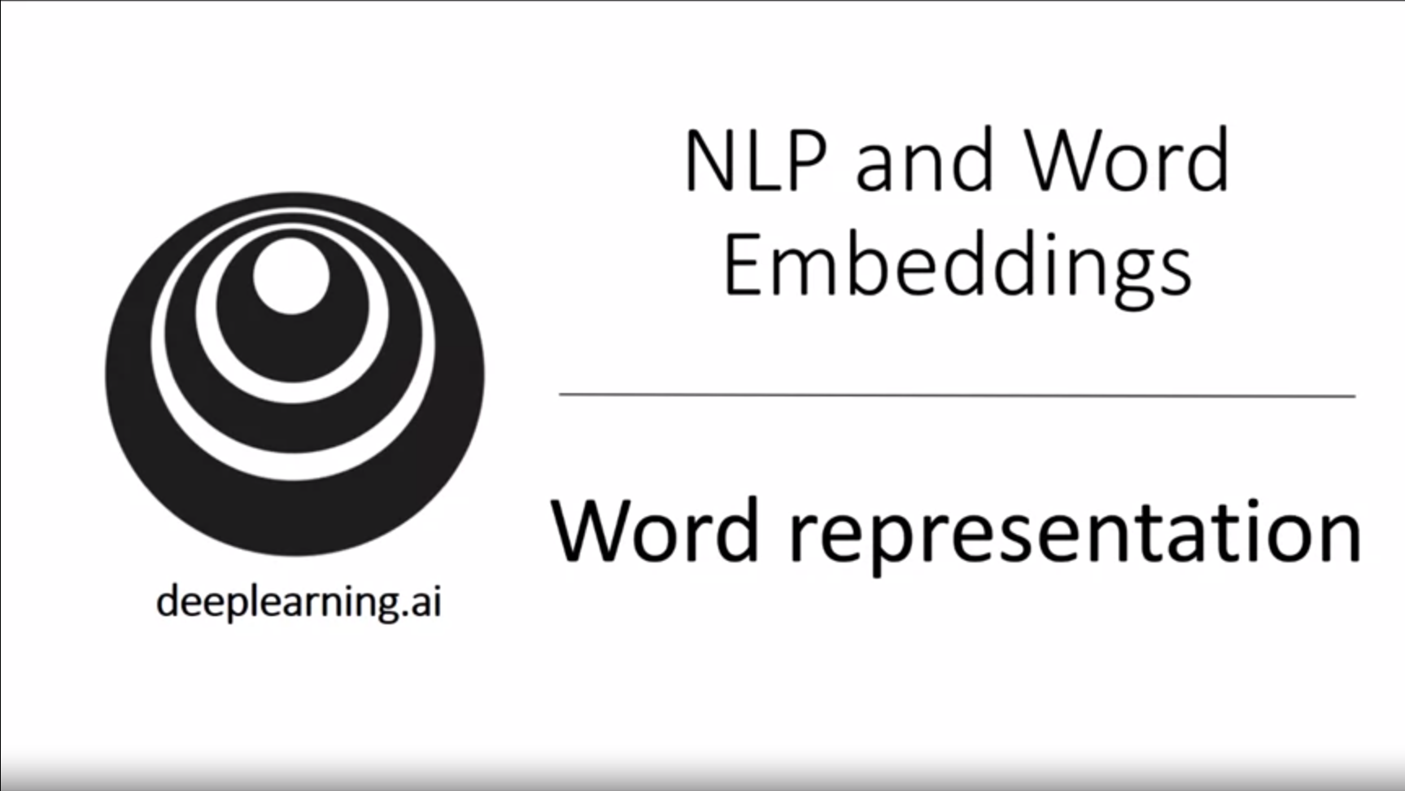

This week will focus on applying sequence models to NLP. This is one of the fields of AI that is really revolutionized by deep learning.

One key idea is word embeddings, which is a way of representing words that lets algorithms understand e.g. analogies.

Word embeddings help us build models even on modest or small-sized training sets.

We will also look at how to debias word embeddings (e.g. gender bias) that NLP algorithms can pick up.

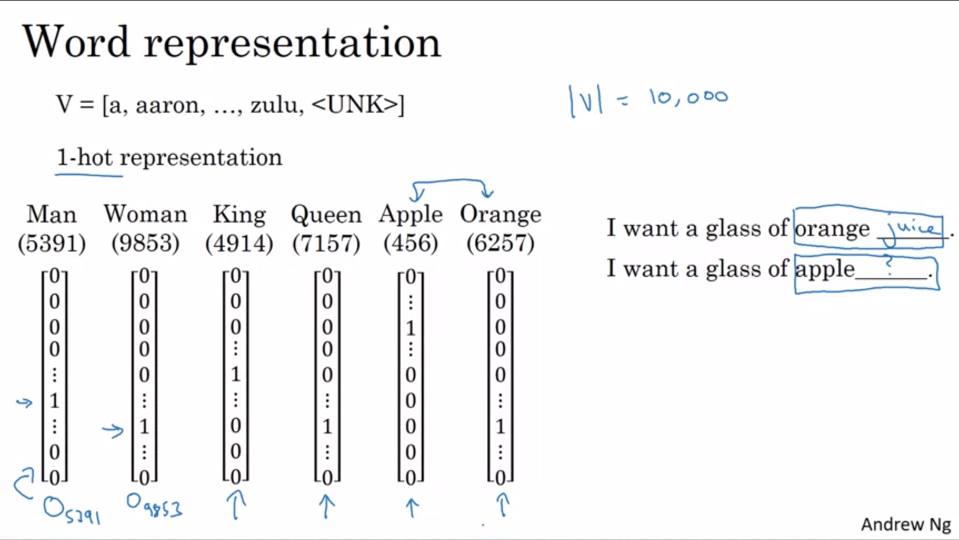

So far one-hot representation of words. This does not allow an algorithm to easily generalize across words. Example sentence on the slide. The learning algorithm might have learned that orange juice is a likely sentence but it cannot generalize to apple juice. The relationship between apple and orange is not any closer than the relationship between any of the other words. Therefore it is not easy to generalize from orange juice to apple juice. The inner product between any two different 1-hot vectors is 0. The Euclidean distance between any pair of vectors is the same.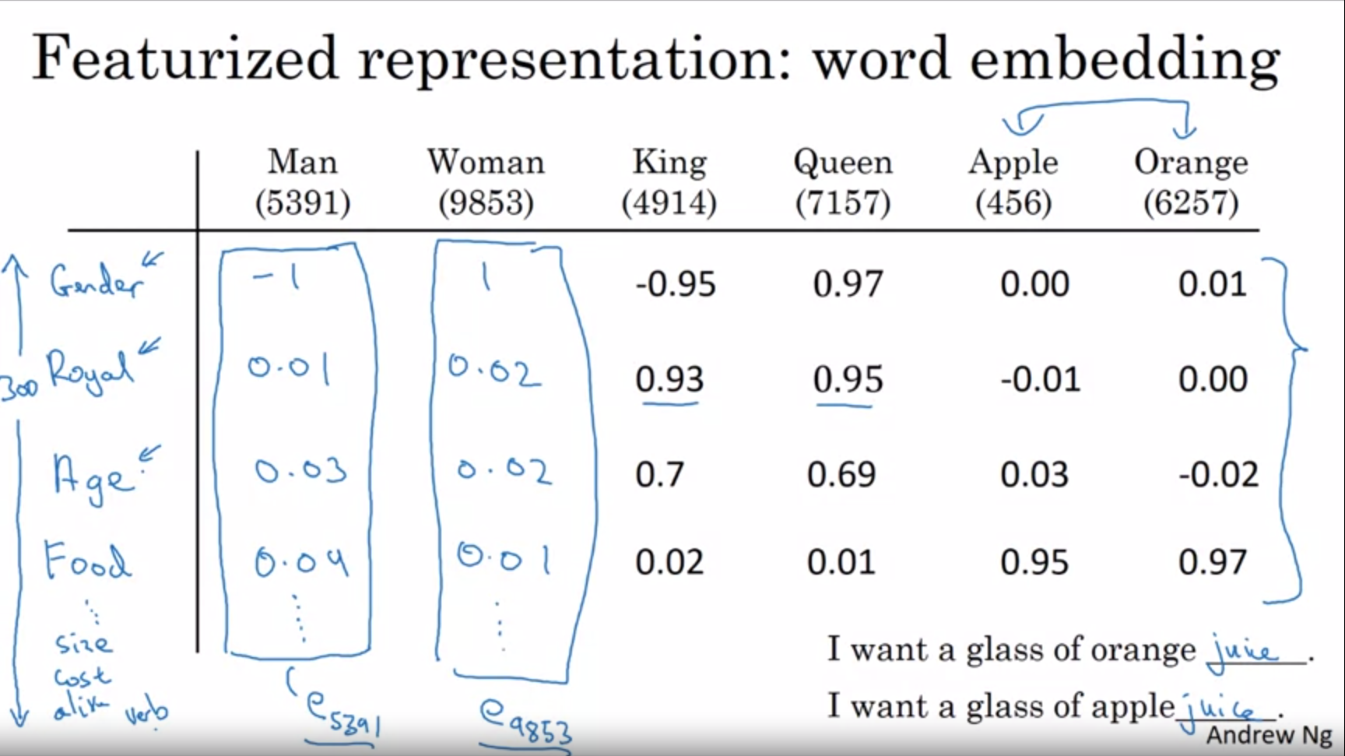  
Wouldn’t it be nice if instead we can learn a featurized representation where for each word we learn a set of values for different features. There could be many features (e.g. here 300, which would lead into a 300-dimensional vector representation).

If we use this representation to represent the words orange and apple then the representations will be quite similar (some features might differ like color and taste but by and large they take on similar values). This can help the algorithm generalize across fruits for example.

The features that we will learn with embedding algorithms will not have an easy to interpret dimension. It will be a bit harder to figure out what exactly they are representing.

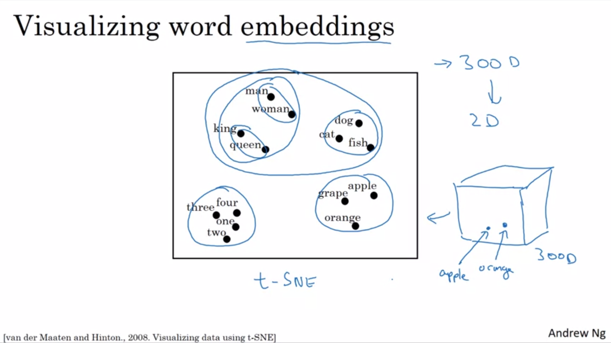

One of the popular things to do is also to take this 300D data and embed it into a 2D space so that it can be visualized. One common algorithm to do this is the t-SNE algorithm.

Concepts that feel more similar to us will likely be mapped close together in the space.

Word embeddings has been one of the most important ideas in NLP.

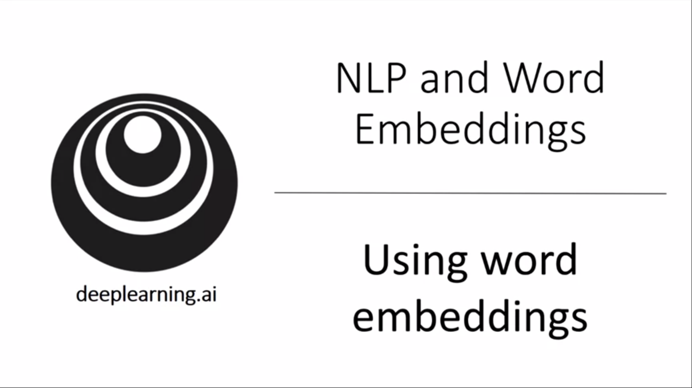

In this section we will see how we can use the learned representations / embeddings and plug them into NLP applications.

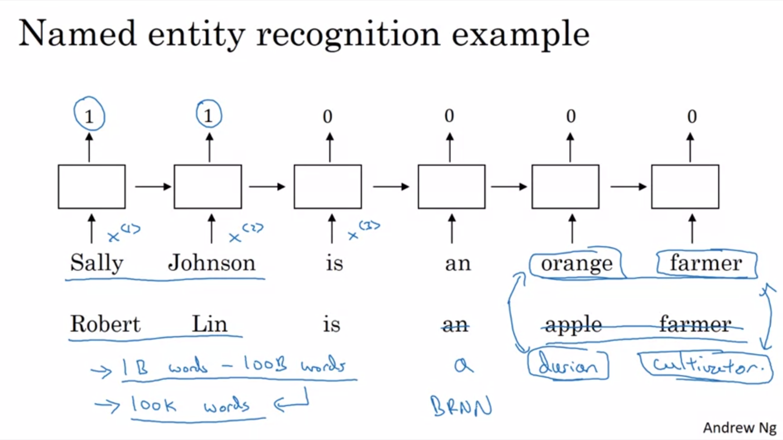

Let’s continue with the name entity recognition example. One way to learn that Sally Johnson is a person and not a corporation for example is that orange farmers should be a person.

Previously we represented words with 1-hot representation. If we now represent words with feature representations instead we will make it simpler for the algorithm to recognize that Robert Lin is also a person. This is even more important if we have a bit rarer words such as durian cultivator which in a small training set, the algorithm might not even have seen.

With word embeddings we can learn that durian is a fruit and that cultivator is something like a farmer so we will be able to generalize even without having seen these words.

One of the reasons why word embeddings can do this is that the algorithms that learn word embeddings can examine very large datasets from the internet, e.g. 1B – 100B words (unlabeled text).

So what is done is that word embeddings are trained on massive amounts of unlabeled text and then can be used in a supervised prediction task on only a small set of data. We carry out transfer learning to be able to better solve the name entity recognition task.

For name entity recognition it makes sense to use a BRNN.

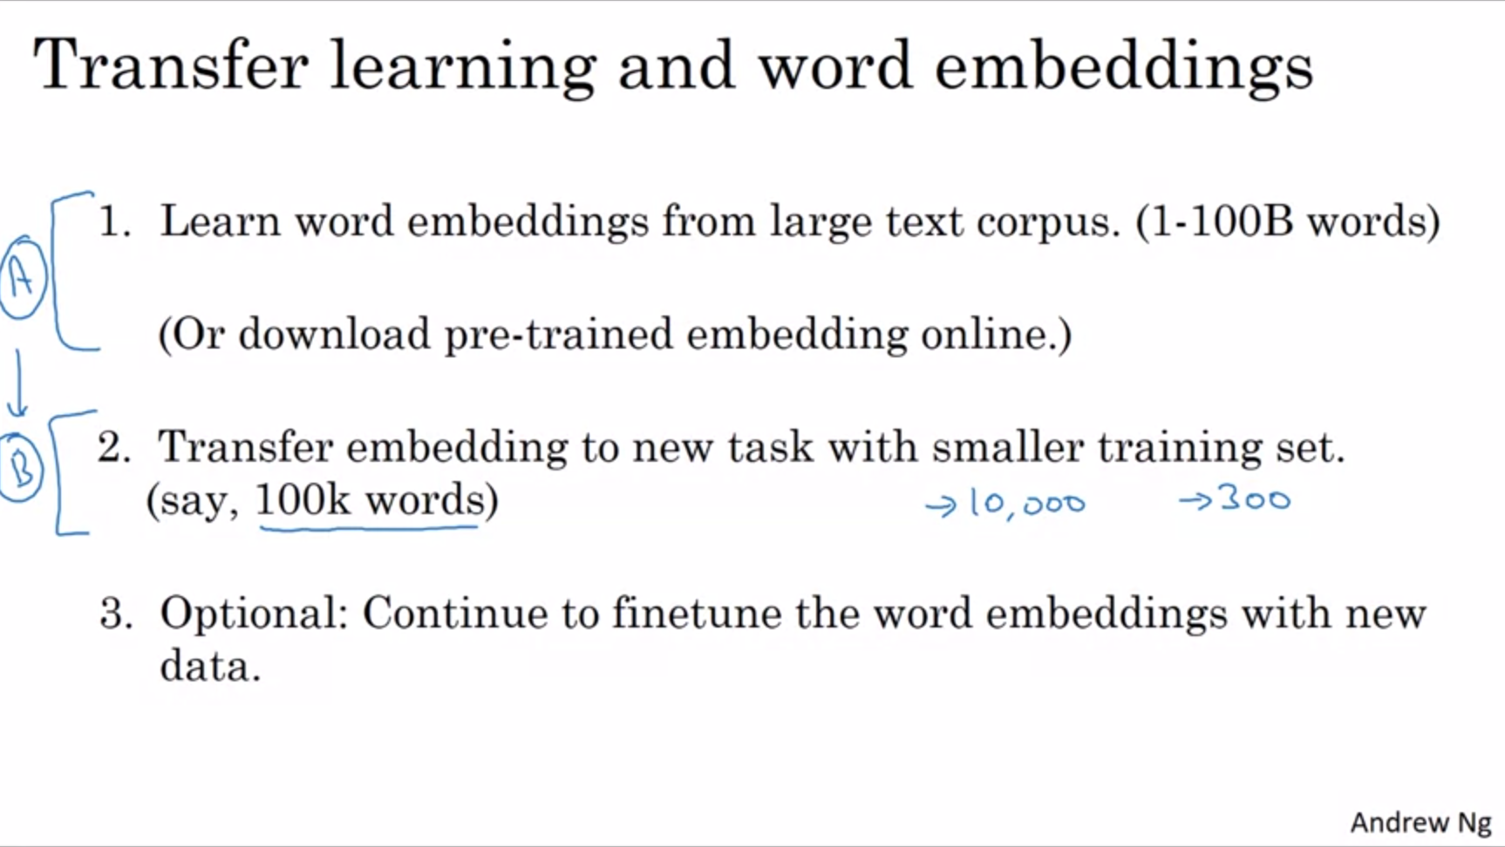

Another advantage is that we can now use relatively lower-dimensional feature vectors. E.g. instead of using 10k 1-hot vector we can now use a 300-dimensional feature vector. However, the 1-hot vector was sparse and the feature vector now is dense.

Step 3 can only be done in practice if step 2 has quite a big dataset.

Word embeddings make the biggest difference if the task that we try to carry out has a relatively small dataset.

Embeddings have been useful for many NLP tasks such as name entity recognition, text summarization, coreference resolution, parsing.

It has been less useful for language modeling and machine translation (especially if we have a lot of data for these tasks).

Transfer learning is most useful if we have a ton of data for A and small data for B. This is less true for language modeling and machine translation settings.

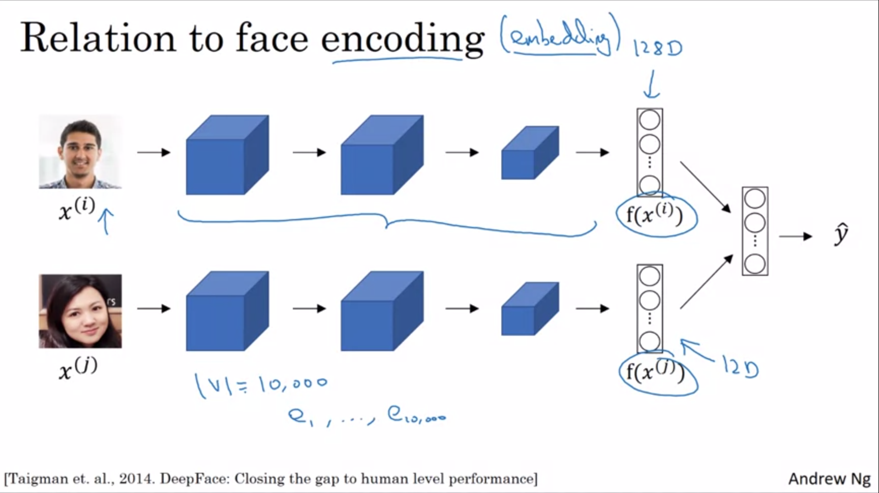

Word embeddings have an interesting relationship to face encoding. In a previous course we built 128D encodings of faces. Then we compared these encodings to see whether two pictures are of the same face.

Embeddings and encodings mean fairly similar things. In the face recognition literature people use the term encoding to refer to these vectors. One difference between face recognition and word embeddings is that in face recognition we want to input any face (even ones that algorithm has not seen before) and compute an encoding for that new picture whereas for learning word embeddings we will have a fixed vocabulary of e.g. 10k words and we compute an embedding for each of these words in our vocabulary.

The terms encoding and embedding are used somewhat interchangeably. The difference explained in the previous sentence has nothing to do with terminology.

We have seen that by replacing one-hot vectors with word embeddings we can benefit from transfer learning, learn much better from less labeled data and generalize better.

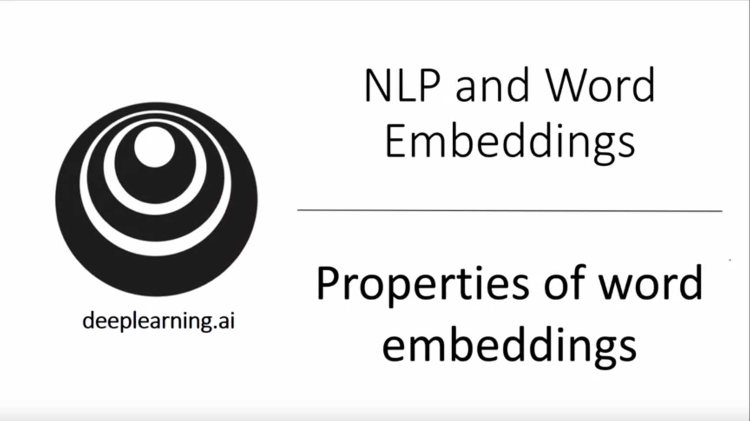

One of the fascinating properties of word embeddings is that they can also help with analogy reasoning. This characteristic also helps us make sense of what these word embeddings can do.

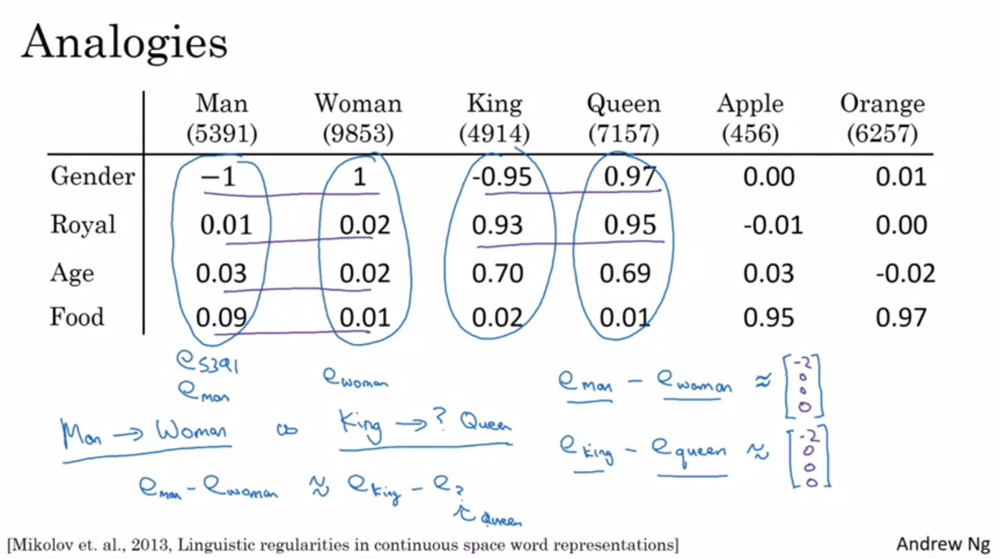Here we have featurized word embeddings.

What is to King as Woman is to Man? Here we use a simple example with 4D embeddings.

Subtract e(woman) from e(man). The result is similar if we subtract e(queen) from e(king).

The main difference between the two is gender for both pairs.

The algorithm can find a word so that the subtraction gives the same results.

The paper on this slide first pointed out these ideas. It is quite an influential result for intuitions of word embeddings.

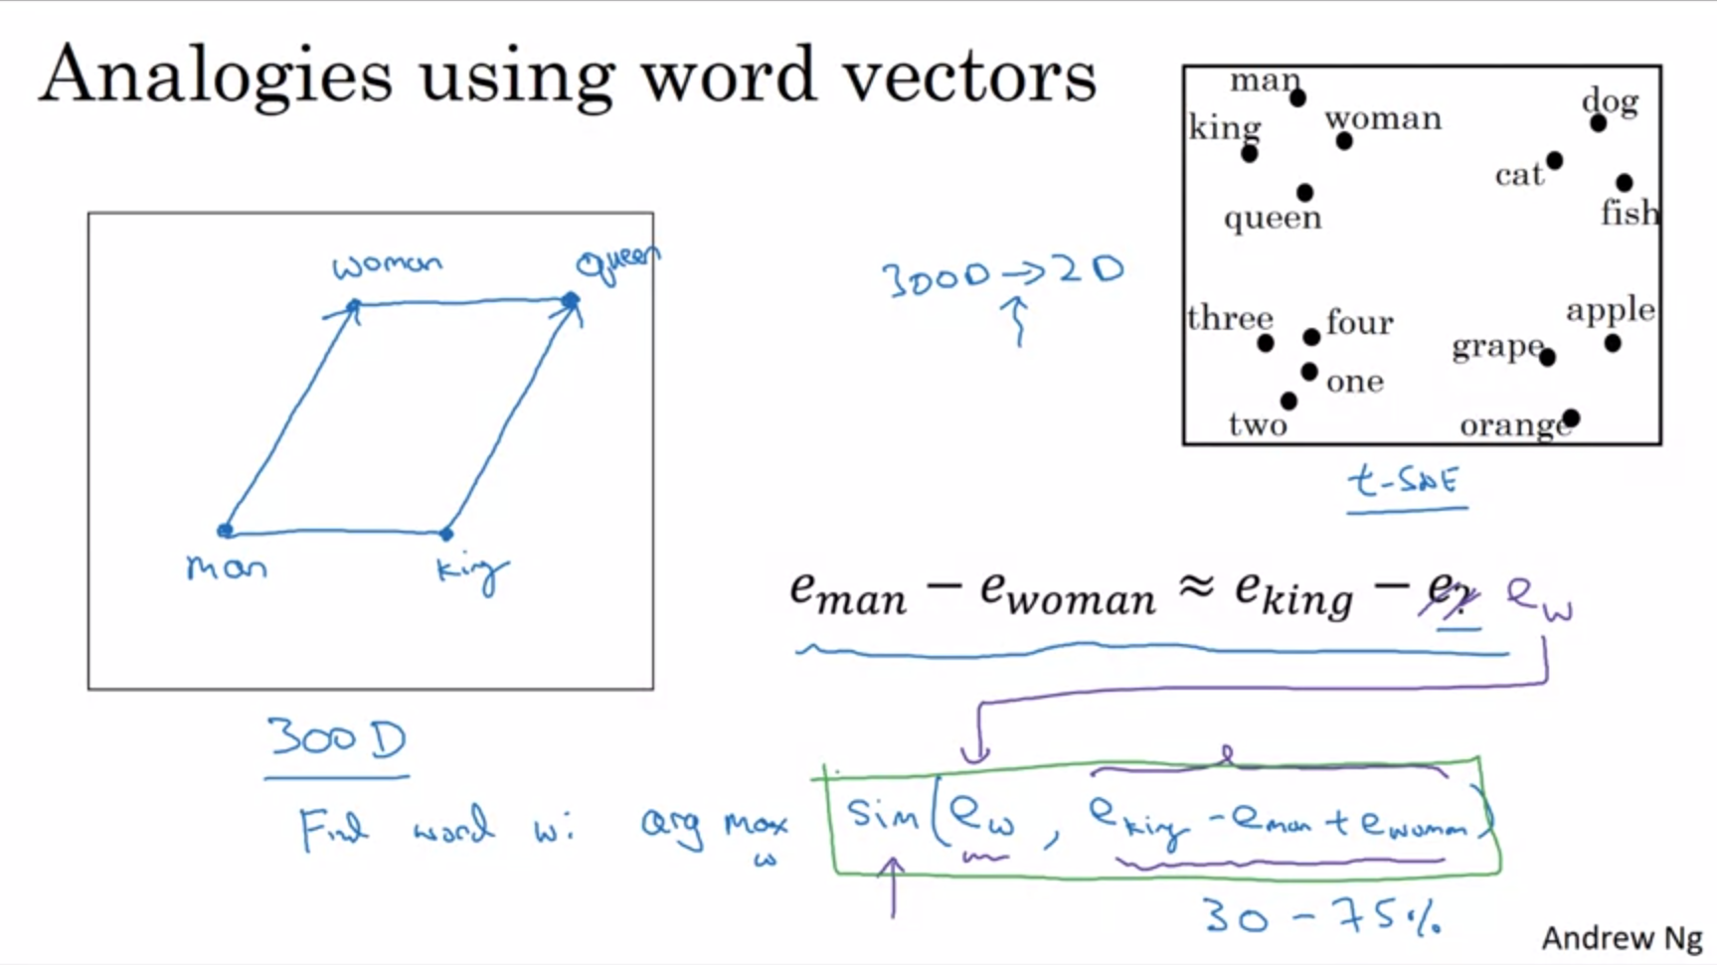

The vector difference between the two pairs is very similar.

Find word w so that green equation holds true (with sim -> similarity).

Replace e(?) with e(w).

The remarkable thing is that this really works with learned embeddings. It is not uncommon for research papers to report 30%-70% accuracy on analogy reasoning where you only count it as correct if it gets the one word defined as analogy.

t-SNE maps in a very non-linear way into a 2D space. The mapping that t-SNE learns is a very complicated and non-linear mapping. After the t-SNE mapping you should not expect parallelogram relationships to hold true. This only holds true in the original feature space.

Different similarity functions could be used to calculate sim.

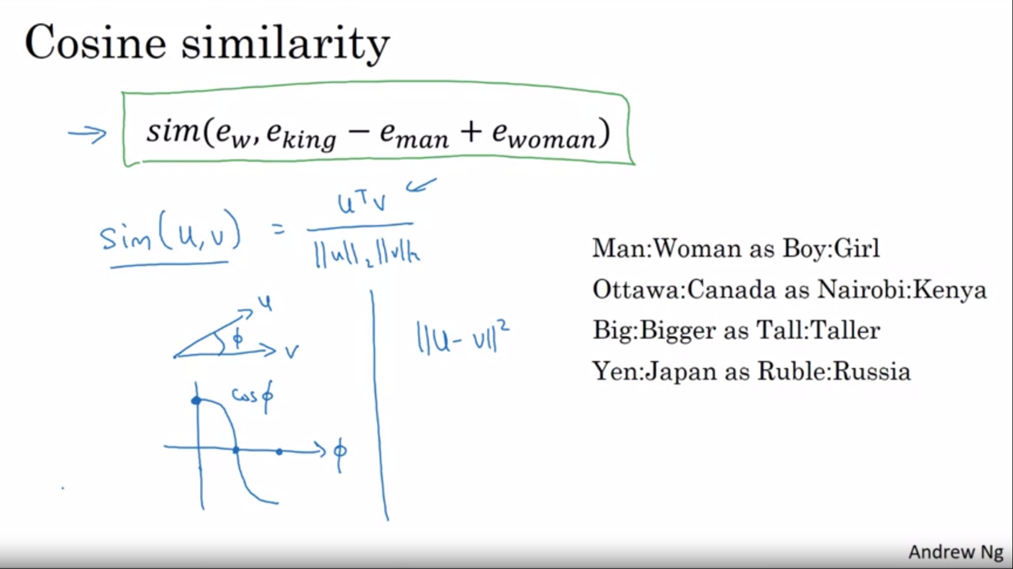

Cosine similarity is a very common function to calculate similarity.

Ignoring the denominator, the cosine similarity is basically the inner product between u and v. If u and v are very similar, the inner product will tend to be large.

The division is by the Euclidean length.

This is called cosine similarity because it is actually the cosine of the angle between the two vectors u and v.

0 degree angle -> cosine similariy is 1

90 degree angle -> cosine similarity is 0

180 degree angle -> cosine similarity is -1

Euclidean distance can be used as another similarity measure (technically non-similarity measure so we need to take the negative). Cosine similarity is used more often. The main difference between these is how it normalizes for the length of the vectors u and v.

Embeddings learn very general analogies (see examples on the slide) just by learning from a large corpus of text in an unsupervised manner.

Analogy reasoning provides intuition about learned feature representations even if analogy reasoning by itself might not be a system that we want to build.

We learned that cosine similarity can be used to compare two word embeddings.

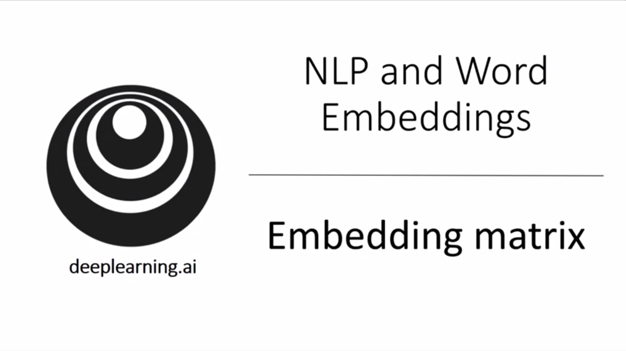

How to learn these word embeddings? Let’s formalize the problem.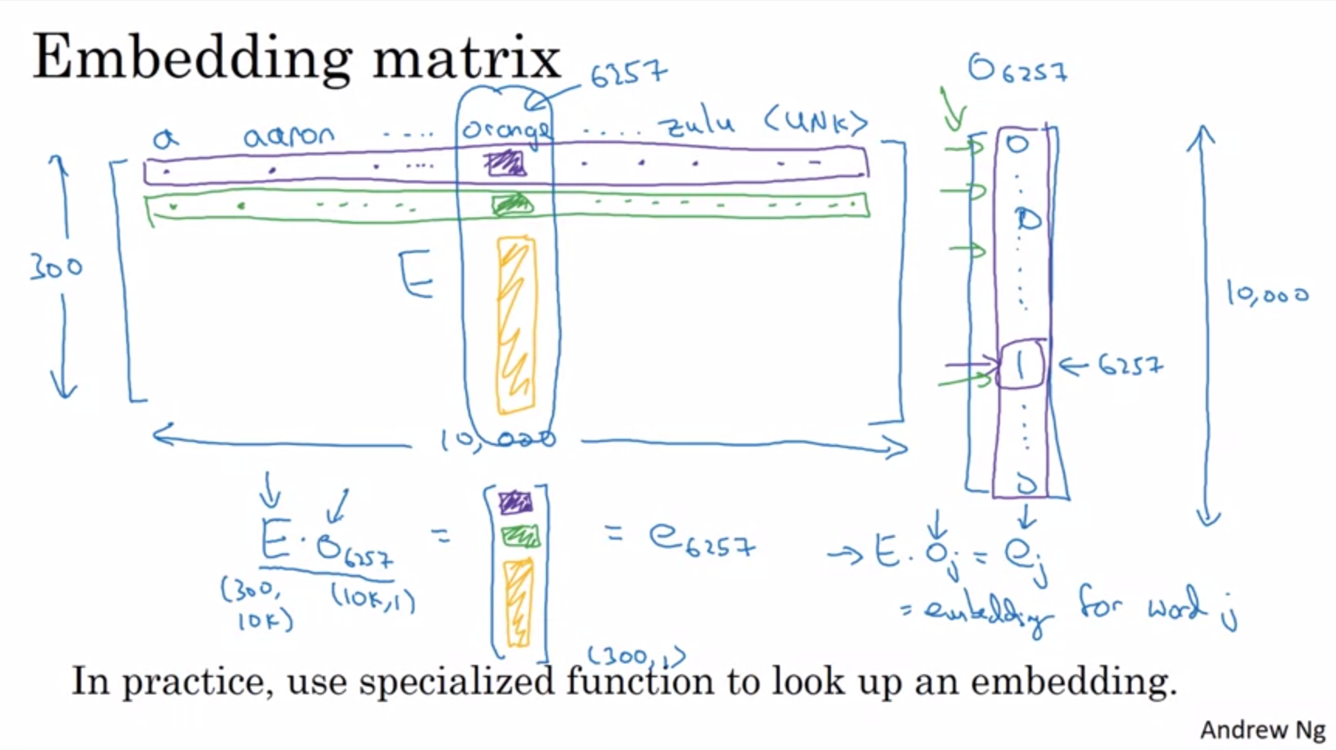

As usual we are using our 10k vocabulary. Learn an embedding matrix E with dimensions 300D by 10kD.

This is not drawn to scale. 1-hot vector on the right should be as tall as the embedding matrix is wide.

Multiply embedding matrix with 1-hot vector of word j to get the embedding of word j.

Our goal is to learn an embedding matrix E. This matrix will be initialized randomly and then we use gradient descent to learn all parameters of this 300D by 10kD matrix.

It is not efficient to implement this as a matrix vector multiplication in practice (because of sparsity of 1-hot vector). In practice we use a specialized function to look up the column of word j in the embedding matrix to get the embedding of word j.

In this section we saw the notation to calculate the word embeddings. Next we will learn about specific algorithms to learn the matrix E.